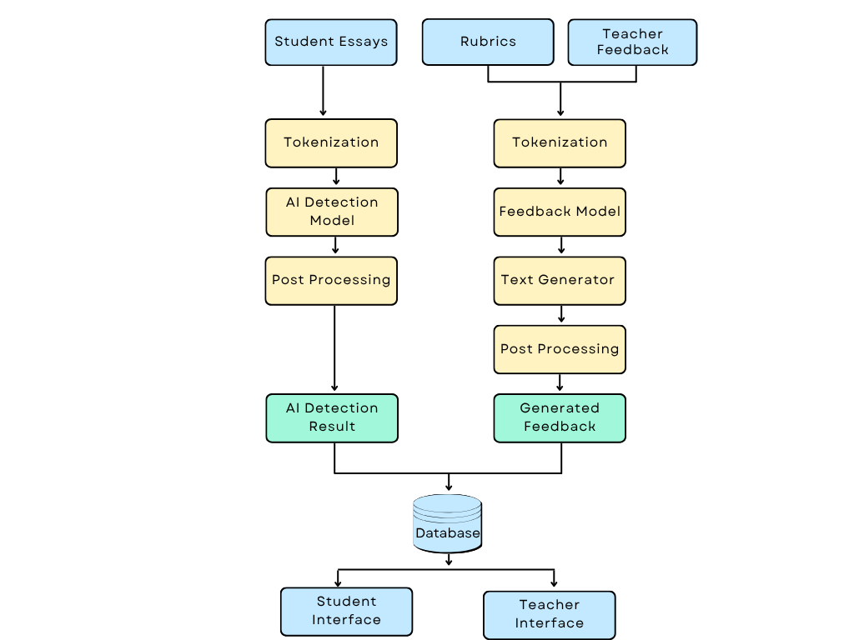

The Data Flow Diagram (DFD) of the AAIE system shows how data flows from input to output through various processing stages. The system starts with three inputs: student essays, rubrics, and teacher feedback. AI detection and feedback generation models are trained on these inputs. In the AI detection flow, the student’s essay is tokenized and passed through an AI model to check for AI-generated content. In the feedback generation flow, rubrics and teacher feedback are tokenized and processed using a feedback model and text generator to create suggestions. After passing the inputs from the model, again, preprocessing is applied to refine and clean the output. The final outputs of both models are stored in a central database. Teachers and students can access the data through a dedicated interface. This DFD clearly shows how data flows in the system.

